**Problem Solving: Online Bus Reservation System.**

|  | **Problem Statement : Online Bus Reservation System** | | | | | | | | |
| --- | --- | --- | --- | --- | --- | --- | --- | --- | --- |
|  |  |  |  |  |  |  |  |  |  |
|  | **What?** | | | | **How?** | | | |
|  | 1) What are the functionalities or Modules Required?  **Ans:**  **1) Admin**  a) Add the bus  1) What are the details to add?  I) Bus Number  II) Bus Name  III) Driver Name  IV) Driver Number  V) Bus route  VI) Bus Facilities  b) Update the bus  I) Time updation  II) Alternate bus  III) Ticket Confirmation  IV) Bus tracking  c) Delete the Bus  I) Delete unused bus  d) View / View All the bus details  I) Bus Number  II) Bus Name  III) Driver Name  IV) Driver Number  V) Bus route  VI) Bus Facilities  * AC/Non Ac  * Sleeper/Semi Sleeper  * Seat number  * Upper berth/Lower berth  e) Add / Delete / Update / View Fare details  I) Update ticket price  II) Update discount in ticket price  III) Generate Tickets  f) Add / Delete /Update / View Customer details  I) Registration  i) User Name  ii) mobile no and whats app no  iii) Gender  iv) Age  v) mail id (optional)  vi) Password  vii) Confirm Password  II) Login(username,password)  **2)User**  1. Register  What are the required details to register?  1. User name  2. Mobile number  3. Gender  4. Email ID  5. Password  6. Confirm Password  2. Login  What are the required details to register?  1. User name  2. Password  3. Search a bus  1. Search available buses from source to destination  2. Search a bus using filter option  4. Book a bus  1. select no.of.seats  2. Add passengers details  3. Pay ticket amount  4. Received a Ticket  5. Cancel a bus  6. Payment  7. Review  User can also give their reviews about the bus by using mail id  8. Travel History  9. Logout | | | | 01. In the admin panel, enter the bus ID and bus details with  add/delete/view/update by using the Text Bar.  02. In the admin panel, use the drop-down bar to add/delete/view/update  the bus ID and bus details.  03. In the admin panel, add, delete, or update the bus details after the document verification, and your bus will be added to the app and a unique identifier will be generated.  04.In fare, enter route in the textbox to add, delete, or update an option.  05. In fare select the source and destination route with add,delete or update option.  06. After booking, provide the driver and cleaner details to the customer.  07. After booking, don't provide the driver and cleaner details to the customer.  08. Registration done by manually.  09. Registration done with a help of google account.  10. Seat selection count selection by using text box, then seat  will allocate automatically.  11. Seat selection count selection by using increment and decrement button,  then seats will be allocated automatically.  12. Seat selection will be a manual method (manual selection).  13. Show the Travel history in the Main Page.  14. Don't Show the Travel history in the Main Page. | | | |
|  |
|  |
|  |
|  |
|  |
|  |
|  |
|  |
|  |
|  |
|  |
|  |
|  |
|  |  |  |  |  |  |  |  |  |
|  | **Why?** | | | | **Why Not?** | | | |
|  | 01. In the admin panel, add, delete, or update the bus details after  the document verification, and your bus will be added to the app and  a unique identifier will be generated.  02. In fare select the source and destination route with  add,delete or update option.  03. After booking, provide the driver and cleaner details to the customer.  04. Registration done with a help of google account.  05. Seat selection will be a manual method (manual selection).  06. Show the Travel history in the Main Page. | | | | 01. In the admin panel, adding or updating some details without verification  may lead to a technical problem.  02. In fare selection, manual entry may take more time and make more mistakes.  03. By using a Google account, we can access it easily. In case a user forgets  their account password, they can access it easily by using a recovery OTP or recovery mail ID,  which is more secure.  04. Manual seat allocation is the user's almost choice; some users want window  seats,and some users don't like window seats, so manual seat selection is  suitable for this project.  05. Travel history: to track the present places, I want to see  their previous travel details. | | | |
|  |
|  |
|  |
|  |
|  |
|  |
|  |
|  |

**Algorithm:**

**Admin:**

**Step 01:** Start

**Step 02:** Create an admin panel(Login page).

**Step 03:**If the given admin details are valid then goto step 3,else goto step 9.

**Step 04:** Verify the bus documents.

**Step 05:** Add the bus details, Delete the bus details, Update the bus details and View the details by using an individual bus id.

**Step 06:** Add the bus route, Update the bus route, Delete the bus route after adding bus details.

**Step 07:**Admin can Add the customer details, Update the customer details, Delete the customer details .

**Step 08:** Add the driver and cleaner details, Update the driver and cleaner details, Delete the driver and cleaner details.

**Step 09:** Stop.

**Flowchart:**

**Admin:**



***USER :***

***Algorithm :***

***Step 01 :*** *start*

***Step 02 :*** *A new user must register his details in the registration form.*

***Step 03 :*** *After registration login to the application by using user id and password.*

***Step 04 :*** *If the user id or password is incorrect then repeat this* ***step 03*** *again.*

***Step 05 :*** *User id or password is valid goto the next step.*

***Step 06 :*** *Select the source and destination route.*

***Step 07 :*** *Show the Available seats.*

***Step 08 :*** *Book the seats.*

***Step 08 :*** *Pay the amount for booking.*

***Step 09 :*** *Get the ticket from the application.*

***Step 10 :*** *stop*

**FlowChart:**

**User:**

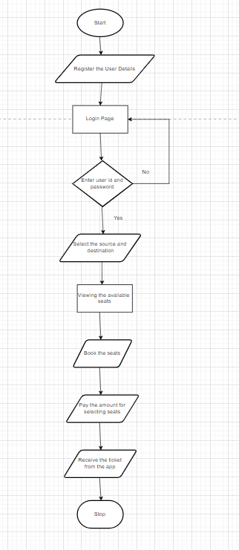

**UML Class Diagram for Admin:**

***UML***

***Admin :***

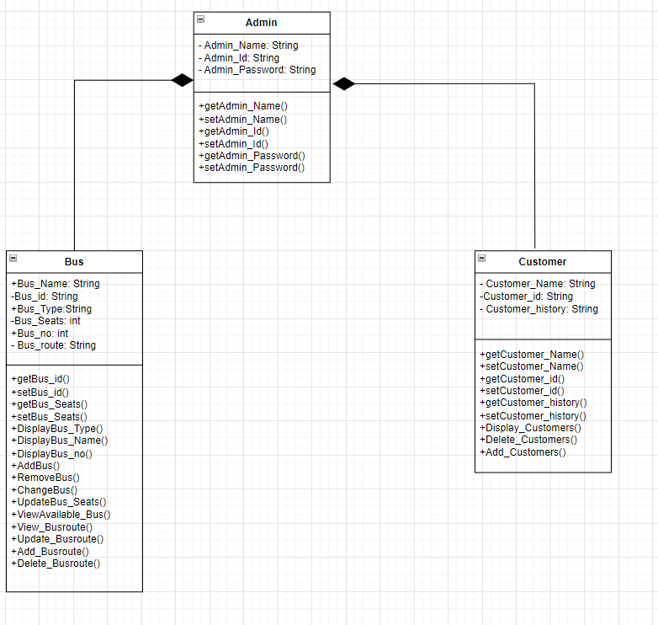

**User:**

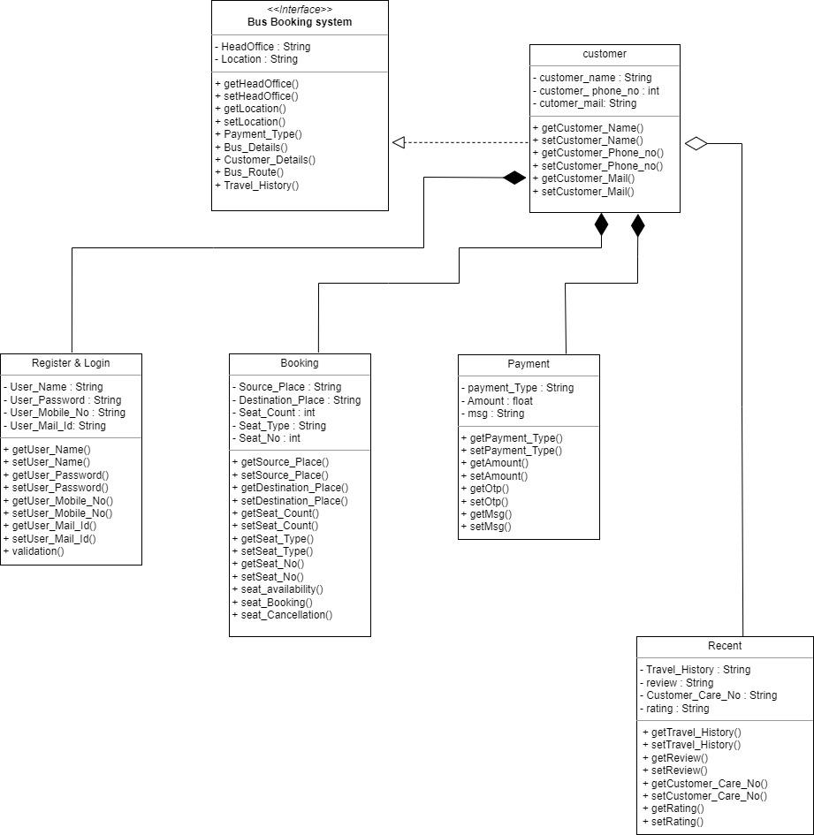

**UseCase Diagram:**

**Admin:**

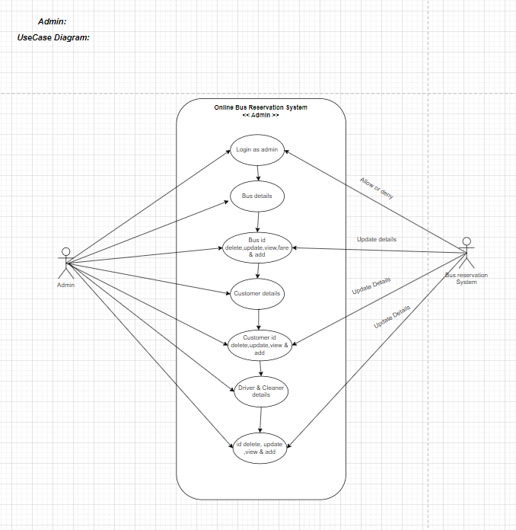

**User:**

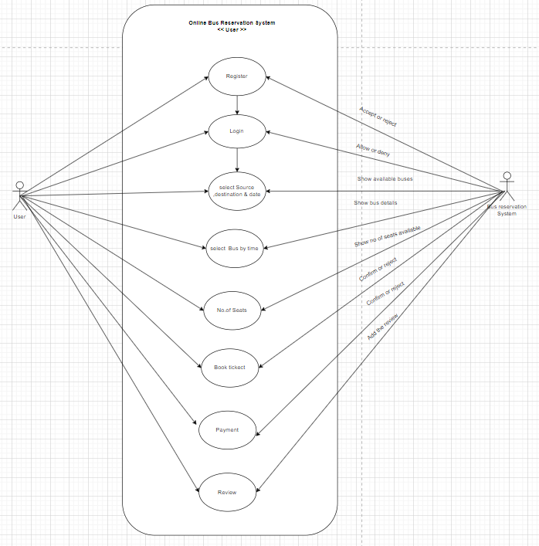

**Sequence Diagram :**

**Register & Login**

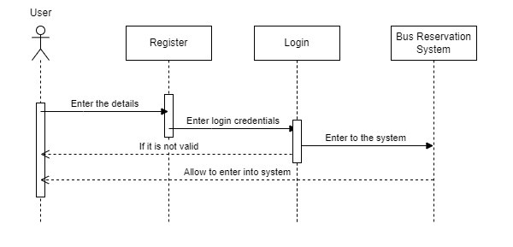

**Bus Fare :**

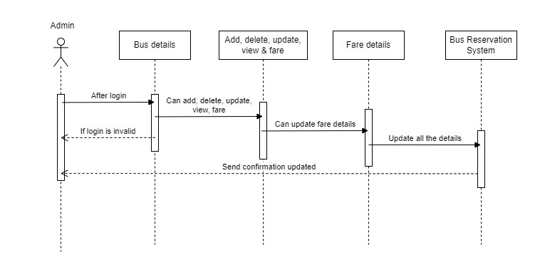

**Customer Details :**

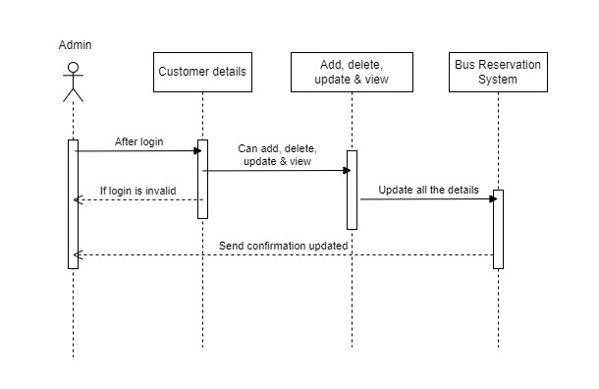

**Driver & Cleaner Details :**

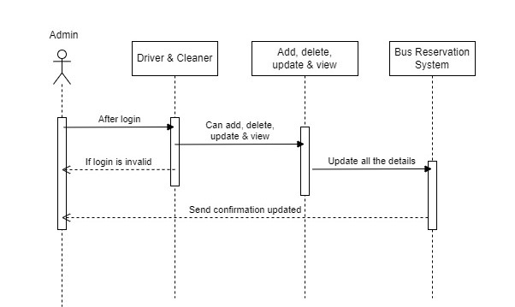

**Booking :**

